Mohamed Sameh Elkholy
RHSA2 - Lab 1

- Use systemctl to view the status of all the system services.
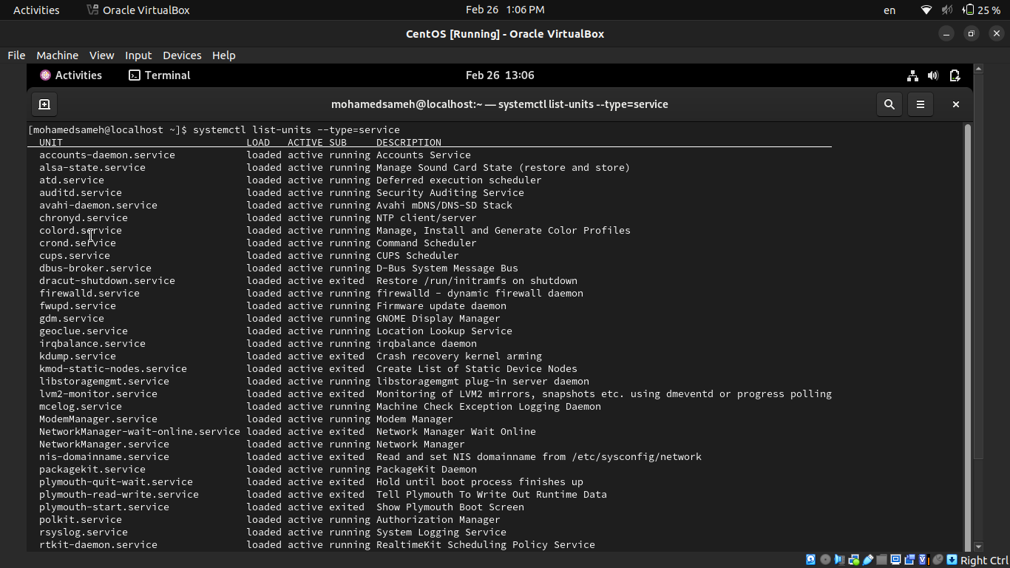
- Change the default run level back to multi-user.target and reboot.
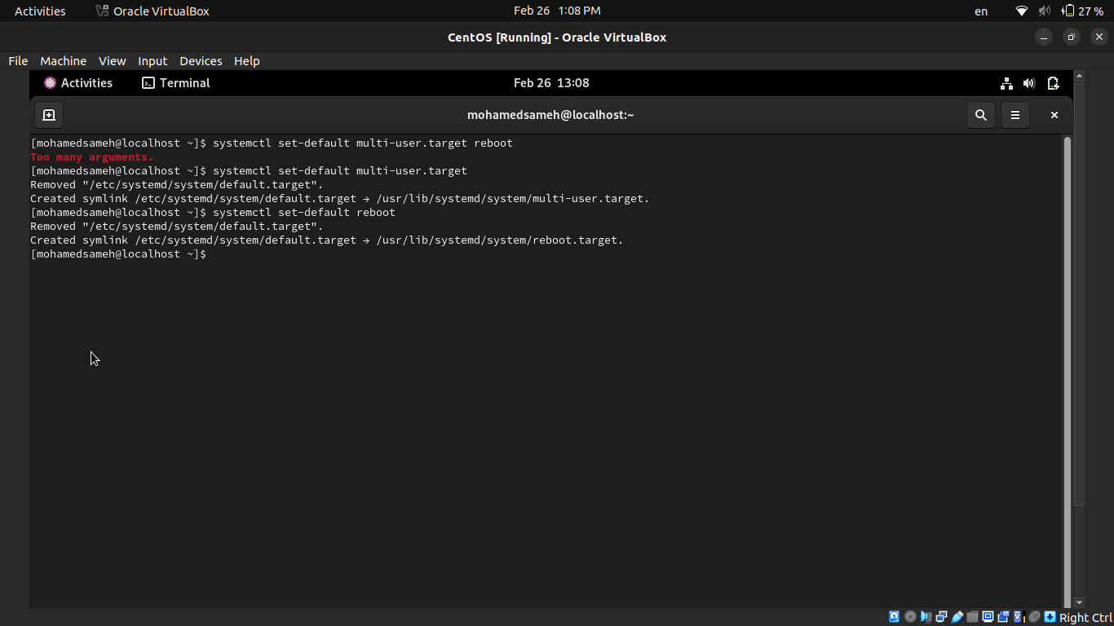
- Send mail to the root user.
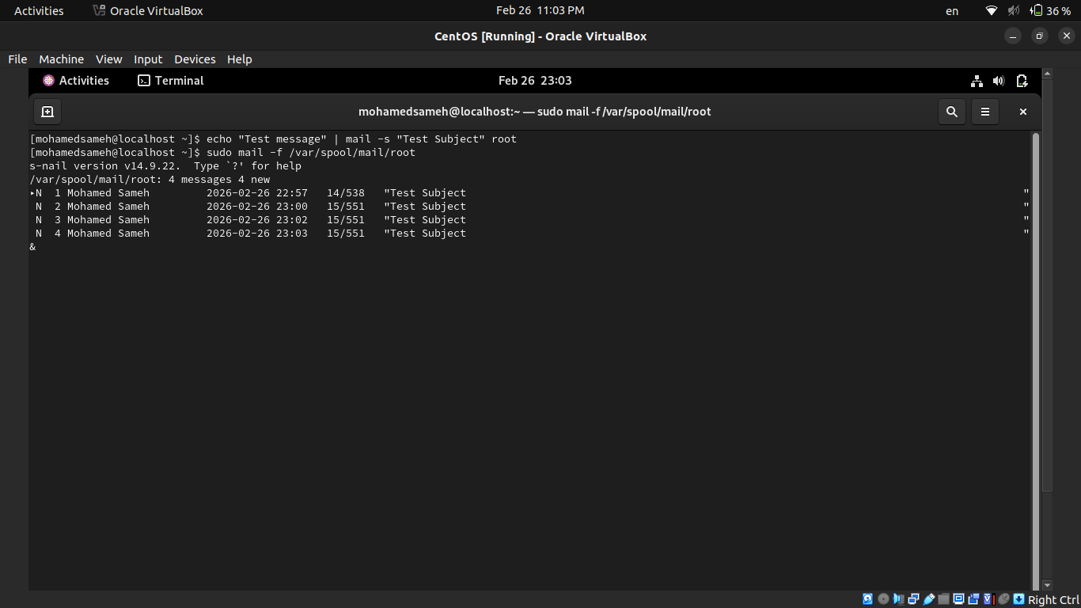
- Verify that you have received this mail.
- Use systemctl utility to stop postfix service
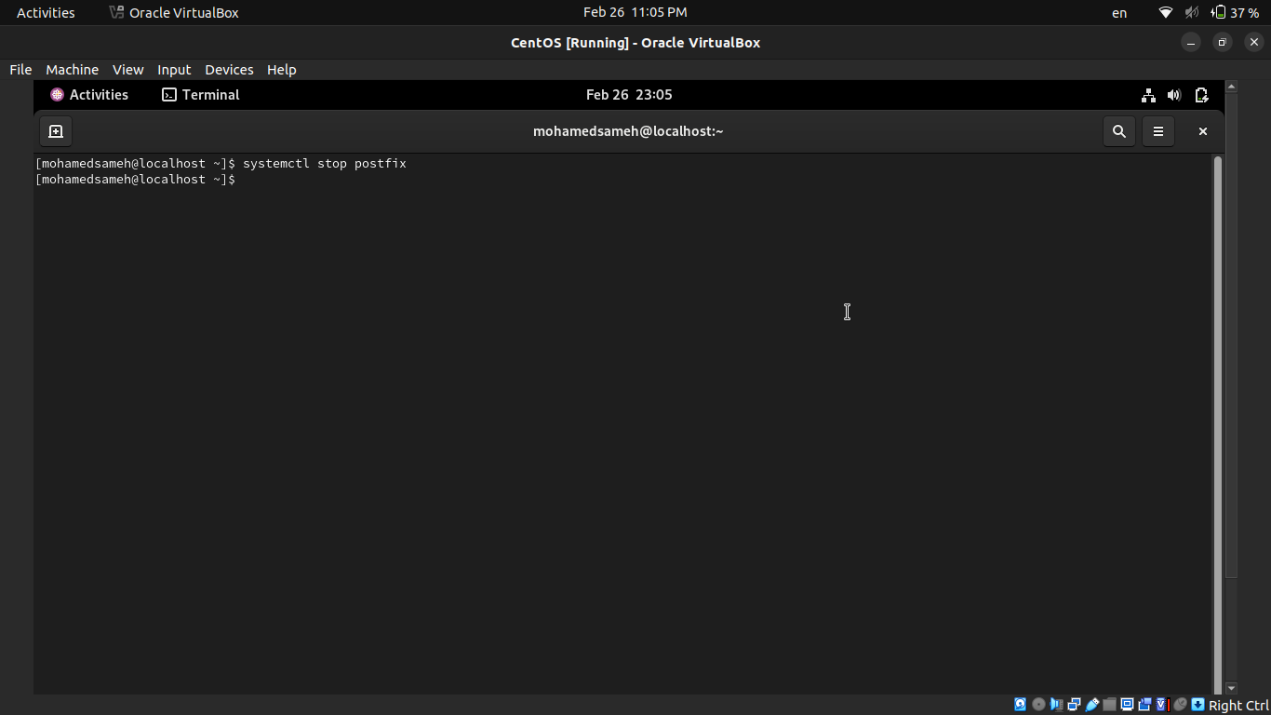
- Send mail again to the root user.
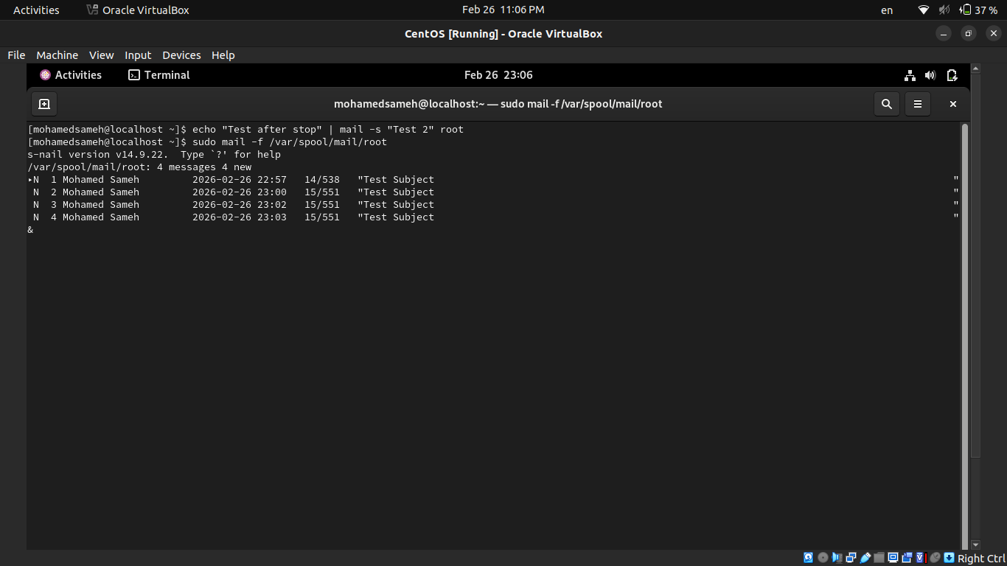
- Verify that you have received this mail.
- Use systemctl utility to start postfix service
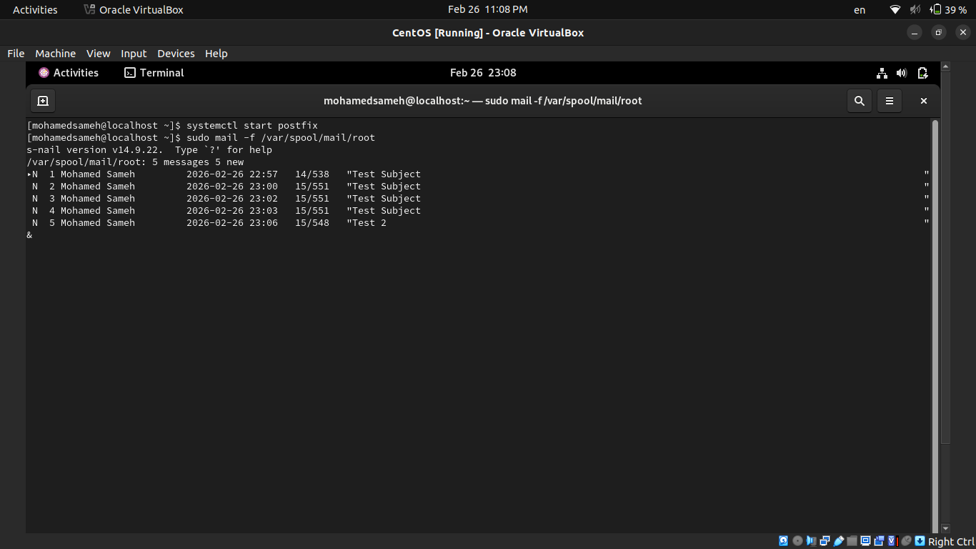
- Verify that you have received this mail.
- Edit in the GRUB2 configuration file and change the timeout variable equal 20 seconds.
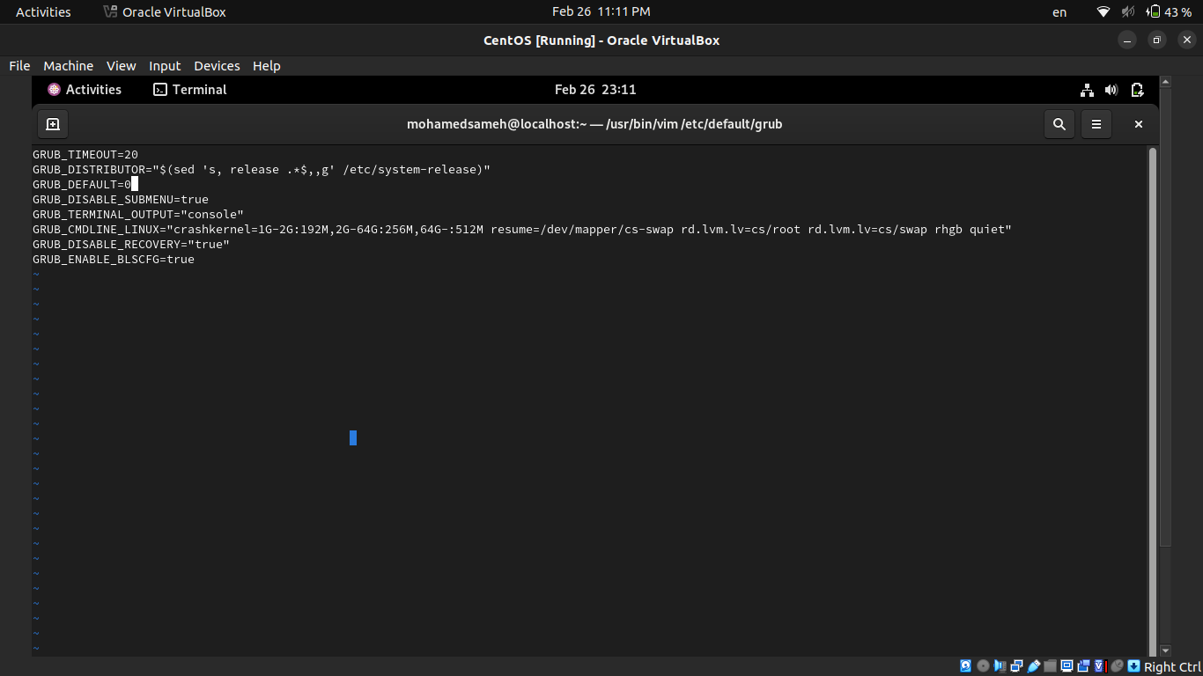
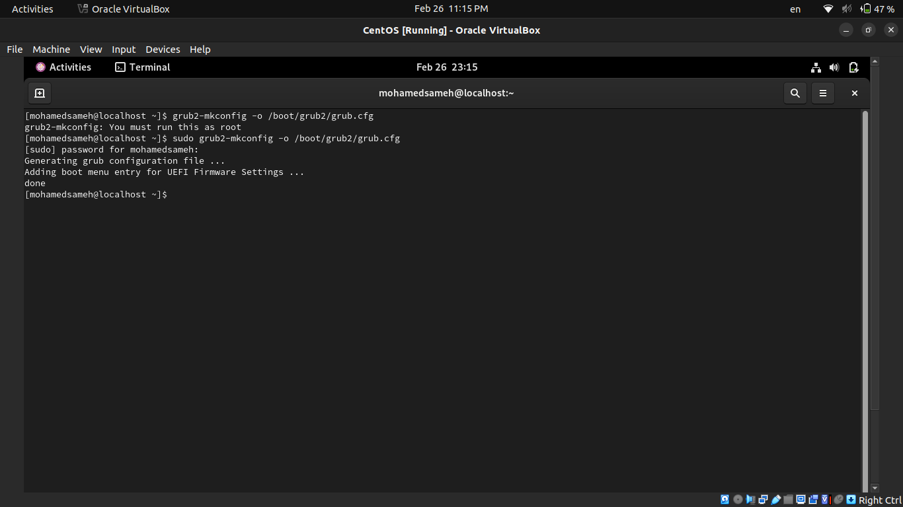
- Edit in the GRUB2 configuration file and change your default operating system
- You want to know some information about the status of the system every ten minutes today between the hours of 8:00 AM and 5:00 PM. to help investigate some performance issues you have been having. You suspect it might be memory related and want to keep an eye on those resources.
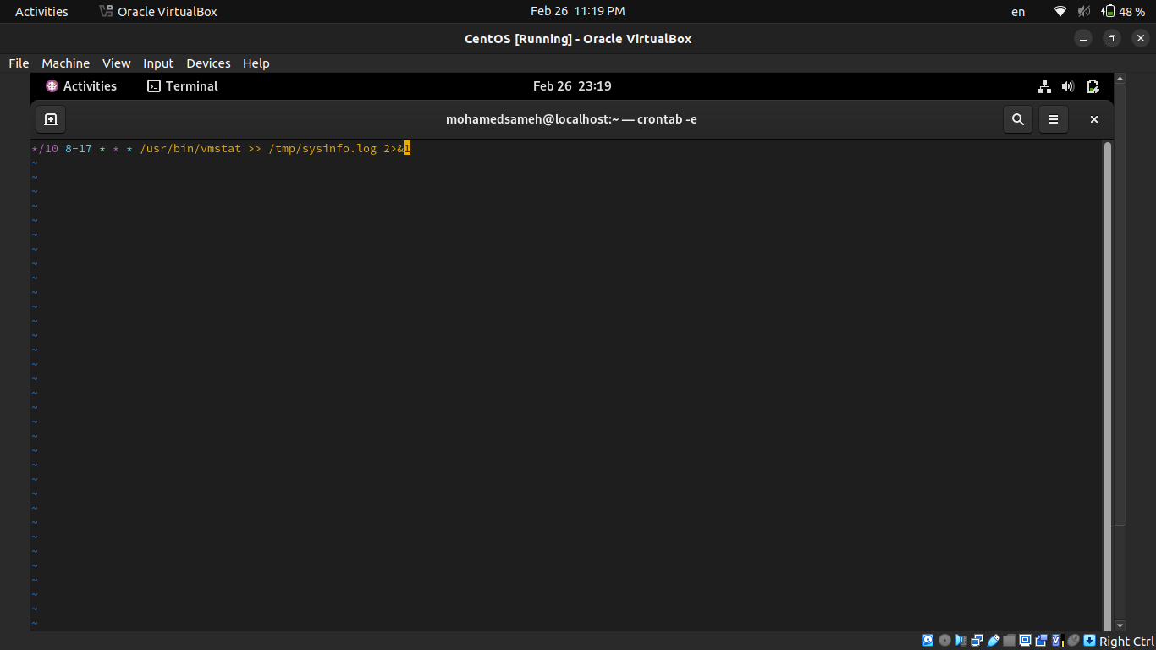
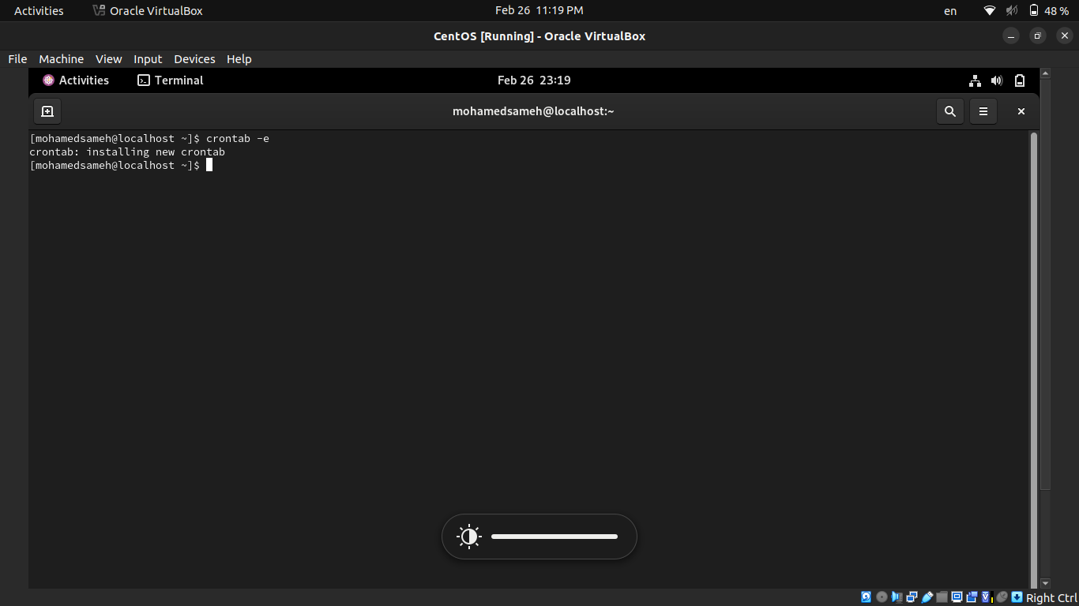
- Use mail as the root user to check for e-mail from the cron jobs you have scheduled.
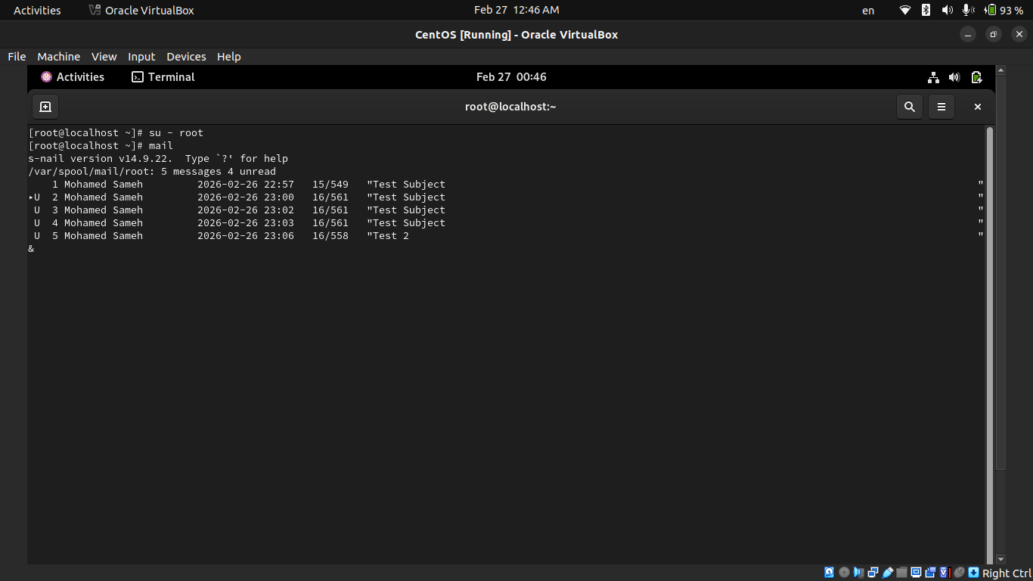
- How could you send the output from these cron jobs to another e-mail address (the manager user)?
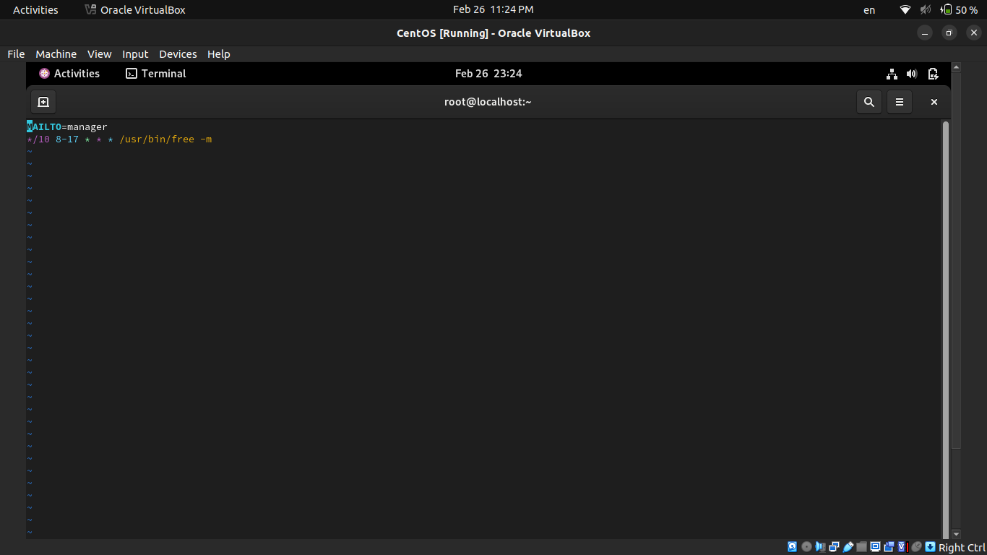
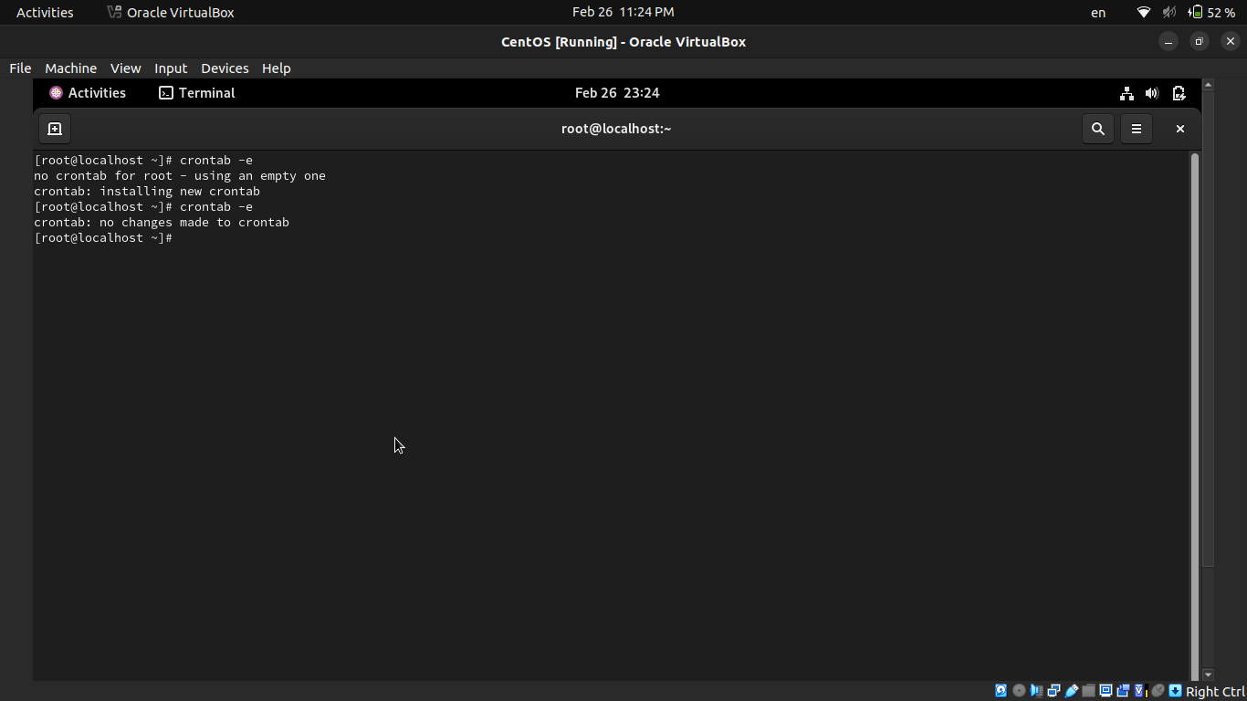
- Use mail as the manager user to check for e-mail from the cron jobs you have scheduled.
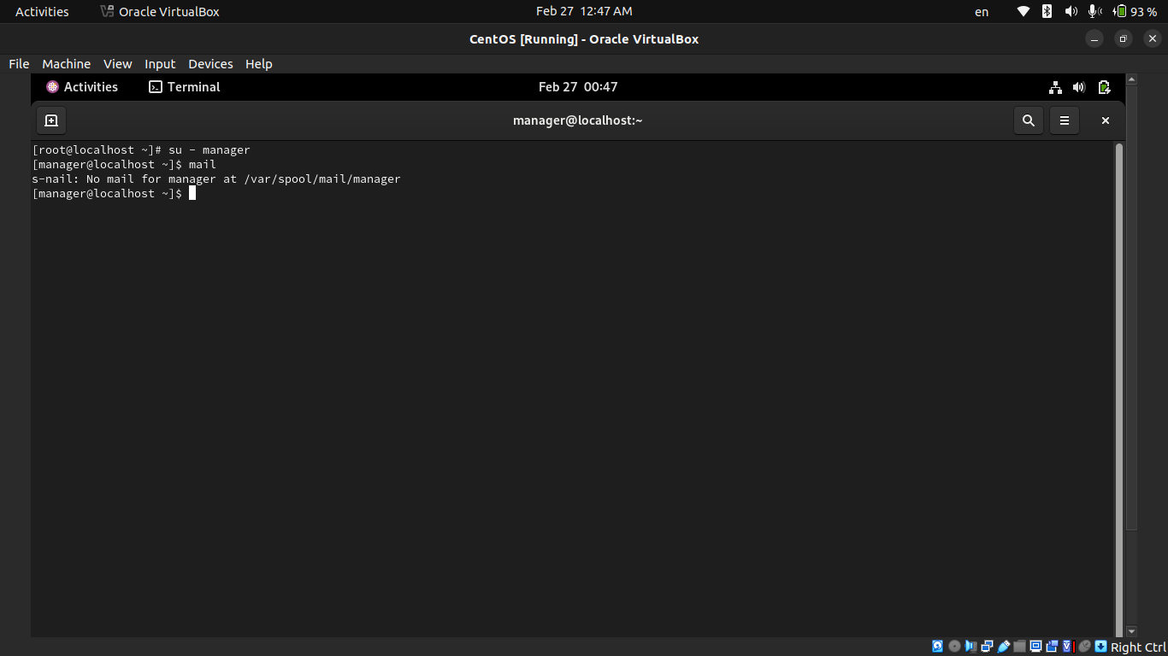
- Grand your colleagues a collective directory called /opt/research, where they can store generated research results. Only members of group profs and grads should be able to create new files in the directory, and new file should have the following properties:
- the directory should be owned by root
- new files should be group owned by group grads
- group profs should automatically have read/write access to new files
- group interns should automatically have read only access to new files
- other users should not be able to access the directory and its contents at all.
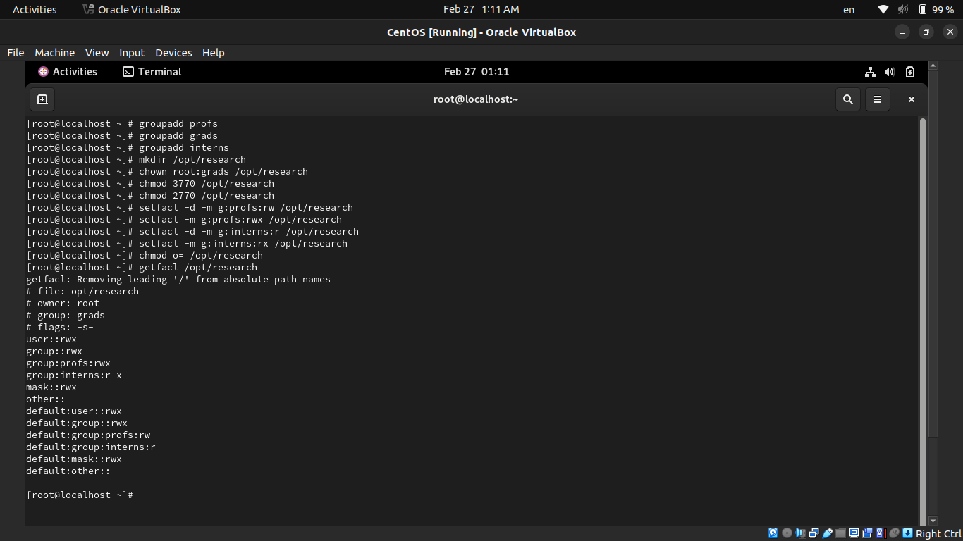

- Display your MAC address by 2 different ways.
- Display the network settings of all active interfaces.
- Display the network setting of all interfaces both active inactive.
- Bring your interface down.
- Configure your network card to have static IP.
- Bring your interface up.
- Verify your network setting using ifconfig command
- Configure your network card to have dynamic IP using network manager command.
- Check using ifconfig then check its configuration file.
- Reconfigure your network card using system-config-network utility to have static IP.
- Configure your network card to have 3 IPs and check that they are all working using ifconfig command.
- Change your host name in your global network file.

Your boss thinks it’s a great idea to have one central logging server. Satisfy his requirements ☺
Hint:
Set up rsyslogd on the "logging server" machine to accept logging messages from other machines.
On the your "workstation", set up rsyslogd to send messages to the "logging server
Test the new setup by using the logger command on the "workstation" to generate a log message
Does the message appear in the "logging server's" /var/log/messages file?
Why does this message also appear in the "workstation's" /var/log/messages file?
- How could you have the message only appear in the "logging server's" files?

